Display Subsystem Power Measurement
Recommendations

Revision 2.0

The document and information contained herein is not a license, either expressly or impliedly, to any intellectual property owned or controlled by any of the authors or developers of this publication. The information contained herein is provided on an “AS IS” basis, and to the maximum extent permitted by applicable law, the authors and developers of this document hereby disclaim all other warranties and conditions, either express, implied or statutory, including but not limited to, any (if any) implied warranties, duties or conditions of merchantability, of fitness for a particular purpose, of accuracy or completeness of responses, of results, of workmanlike effort, of lack of viruses, of lack of negligence. ALSO THERE IS NO WARRANTY OR CONDITION OF TITLE, QUIET ENJOYMENT, QUIET POSSESSION, AND CORRESPONDENCE TO DESCRIPTION OR NON-INFRINGEMENT.

*Other names and brands may be claimed as the property of others.
Copyright © 2008 by Mobile PC Extended Battery Life Working Group. All rights reserved.

Revision History

Revision | Date Changes Made | Comments
2.0 | 11-12-2008 | Publish revision to EBL website

Contents

Revision History 2
Contents 3
Objective 5
Introduction 5
LCD Display Module Anatomy 6
Equipment 8
Measurement Environment 9
Electrical Environment 9
Physical Environment 11
Panel Measurement Configurations 12
Measuring WLED Panel Power Consumption 12
Measuring CCFL Panel Power Consumption 13
EBL Power Consumption Report 14
Warm-up period 15
Backlight Level 15
Temperature 15
Pixels 15
TFT Power 16
Backlight Data 16
Total EBL Power 16
Light Measuring Technique 17
EBL Flowchart 17
Black-White Checkerboard at 60 nits 17
Black-White Checkerboard at maximum brightness 18
Full White pattern at maximum brightness 18
Full Red pattern at maximum brightness 19
Full Blue pattern at maximum brightness 19
Full Green pattern at maximum brightness 19
Full Black pattern at maximum brightness 19
Reference Documents 20
Definitions 20
Appendix A – Alternative to DMM tool 21
Appendix B – Configuration using CRB 22
Appendix C – Efficiency Measurements 22
Configuration to compute CCFL inverter efficiencies 22
Configuration to compute LED efficiencies 23
Appendix D – EBL Levels Report 24
Level Procedure 24
EBL Level Configuration 24
EBL Level Flowchart 25
Level Report 25

Display Subsystem Power Measurement Recommendations

Objective
This document is intended to define a standard method of measuring power consumed in a portable computer by the LCD display module. Use of the process defined within this document will reduce variables in the power consumption process and aid in side by side comparisons of LCD modules.
This document is not meant to replace system level power consumption processes and techniques. The EBL power measurement process is a component characterization tool only.

Introduction
The display subsystem constitutes a significant portion of the overall power consumed by a portable computer. Among the various components and subsystems within a portable computer, the display subsystem is a large consumer of power. As new display technologies develop with a particular focus on reducing display power consumption, it becomes absolutely imperative that, at a minimum, the display subsystem continues to consume less and less power and keep pace with the downtrend in overall platform power consumption.

Graph shows typical relationship of LCD panel power measured using the MobileMark* benchmark vs. rest of system.

The total display subsystem power consumption includes power consumed by the display panel electronics, as well as the display panel backlight system.
The Mobile PC Extended Battery Life Work Group (EBL WG), http://www.eblwg.org is an industry-wide group of companies working together to extend the battery life of portable computers. The EBL WG has developed these display subsystem measurement recommendations to enable uniform and consistent display subsystem power measurement across the portable computer LCD industry.

These recommendations cover how to measure the panel electronics power, backlight, as well as measurement of screen luminance. Appropriate color patterns, ambient room conditions, and a suggested list of equipment are provided. This paper contains two subsequent sections. The first is an overview and should be understood by a general technical audience. The second is the detailed setup and may require some familiarity with computer and software setup and configuration.

LCD Display Module Anatomy
LCD panel module comprises of two parts the LCD cell and the Backlight:

The LCD Cell includes all the circuitry that produces images on the notebook computer’s screen, the timing controller, the row drivers, and the column drivers. Each pixel is made up of one red, one green, and one blue sub pixel. Images are produced by illuminated pixels with differing levels of red, green, and blue light.

The Backlight illuminates the LCD pixels from behind the LCD Cell. Light is channeled from a light source such as a strip of LEDs (Light Emitting Diodes) or a CCFL (Cold Cathode Florescent Lamp) bulb.

The LCD Module consists of an LCD cell with attached backlight system. There are four common styles:
- VESA CCFL panel with CCFL backlight system that is driven by an inverter. An industry standard for many years.
- “VESA” style LED. A panel with LED backlight system designed to industry standard VESA form factor. “VESA” style LED is intended to be a drop-in replacement for “VESA” CCFL panels.
- Bottom Bent LED panel with control circuitry PCB that is attached to the bottom of LCD cell.
- Flat Type LED panel with control circuitry is mounted at bottom of LCD cell.

VESA CCFL
“VESA” STYLE LED
BOTTOM BENT LED
FLAT TYPE LED
Four most common LCD panel module styles.

Equipment
As with all lab measurements, the quality of the equipment used will directly correlate to the quality and repeatability of measurements. The equipment listed here is for reference only, each test administrator is free to pick and choose tools to meet their business needs.
Tool | Purpose | Contact Information
Photometer | Tools used to measure luminance.  Note: Low end surface contact colorimeters, often used to calibrate display colors, are not recommended for measuring luminance. For most accurate results the use of a photometer is highly recommended. | Photo Research PR-670 / PR-880 www.photoresearch.com  Topcon BM-5AS / SR-UL1R  www.hoffmanengineering.com  Minolta LS-100 / CS-2000  www.konicaminolta.com
Pattern Generator | Tools used to operate LCD display  Note: Portable computers are good pattern generators. | Westar T-drive Model II  www.westardisplaytechnologies.com  Quantum Data QD-882  http://www.quantumdata.com  Astrodesign (http://www.astrodesign.co.jp/english/index.asp)
Power meter | Tools used to measure voltage and current  Note: Good lab grade DMMs are preferred. | Fluke 8845A  http://us.fluke.com  Agilent 33401A / 33405A  www.home.agilent.com  Keithley Instruments KI-2000  www.keithley.com
Thermometer/Hygrometer | Tools used to measure temperature and humidity | Practical Solutions THUM  www.practsol.com
Stopwatch | Tool used to measure time | Sporting goods store or digital kitchen timer source

Measurement Environment

Electrical Environment
- The panel electronics power is strongly influenced by four key variables:
- Screen Refresh Rate
- Resolution (number of pixels)
- Image (pattern) that is displayed on the screen
- Luminance (brightness)

Screen refresh rate, how often each full screen of pixels is refreshed is the largest power consumption variable in the display. 120hz refresh rate consumes more power than 60hz rate refresh, and 60hz refresh rate consumes more power than 40hz refresh rate, etc.
It is permissible and appropriate to use the EBL process to measure panels at refresh rates other than 60Hz. However, power measurements made with a refresh rate other than the EBL “standard” of 60Hz refresh rate should be disclosed as a non-standard refresh rates.
For example if you wanted to compare panels running at 40Hz against panels running at EBL “standard” 60Hz it is suggested that the following reporting notation be used:
(SAMPLE DATA)
EBL = 3.04W
EBL_{40Hz} = 2.50W

The screen resolution (WXGA, WXGA+, WUXGA, …), is a large factor in the power consumption equation. Each pixel is made up of three RGB sub-pixels. Each red, green, and blue sub-pixel requires three or more transistors to function. The higher the resolution, the higher the power consumption, WUXGA consumes more power than WXGA+, and WXGA+ consumes more power than WXGA.

Power measurements should be made at the native resolution of the panel; i.e., don’t measure WUXGA panels scaled down to the WXGA resolutions.

Typical panel logic power consumption WXGA, WXGA+, WSXGA+, and WUXGA

The image displayed on the screen impacts power consumed. Static single color images more often consume less power than full motion video on the screen. To standardize the patterns used, EBL requires that a black-white checkerboard pattern be used for EBL measurements. The checkerboard pattern must completely fill the LCD screen, no black bars or boarders are permitted anywhere on display under test. Checkerboard bitmaps can be downloaded from the EBL website at http://www.eblwg.org.
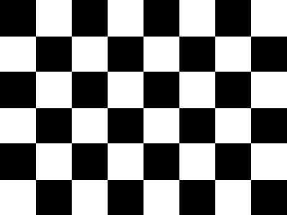
Example of a panel displaying black on white checkerboard pattern

Luminance is a measurement of the panel’s ability to produce white. Traditional unit of measurement in panel luminance is cd/m² (nits). Panel luminance is principally determined by the LCD CELL optical transmission efficiency and the backlight luminance.

Physical Environment
Environmental factors such as ambient light or room temperature can have a strong influence on accuracy and repeatability of panel luminance measurements.
For example a 10°C variation in room temperature can result in a large variation in panel luminance measurements.
To minimize environmental impact on measurements, the following conditions must be enforced on all panel measurements:
Ambient light | ≤ 1 lux
Temperature | 25°C ± 2.5@ 25% - 85% Relative Humidity  Thermometer and Hygrometer placed ≤ 60cm from display
DUT warm-up time | VESA 305-3 or ≥ 30 minutes.
Viewing direction | Perpendicular to panel ± 0.2º
Measurement distance | Any distance from light measurement device (photometer) that will ensure that ≥ 500 pixels are measured.  Examples of known good measurement distances:  - 50cm with 2º aperture measurement device  - 100cm with 1º aperture measurement device

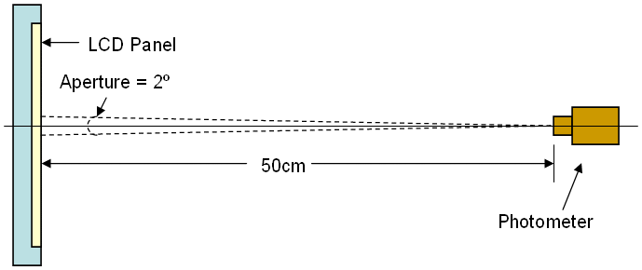
Note: Temperature and Humidity must be measured on or near the panel under test.
Example of typical light measurement device (photometer) and a display under test.

Panel Measurement Configurations

Measuring WLED Panel Power Consumption
BL
data
LED Backlight Controller
LED Driver
Logic Controller

Liquid Crystal Display
Column Driver
Row Driver
LED Light strip(s)
System Power
Backlight Power 12v
DC Current Meter
Example of typical test configuration for power consumption measurements on a LED panel.
On a WLED backlit panel Power is consumed by both data and backlight system. Both systems must be measured individually.
Data is driven from system typically at 3.3v ±10%.
Measure the DC current drawn by the data and backlight as shown above using a quality DMM in “DC Current” mode. Power Consumed = Voltage x Current. Calculate the Power Consumed by each component.
P_{data} = V_{data} x I_{data} and P_{BL} = V_{BL} x I_{BL}
Backlight system is typically driven directly from battery. Batteries can contain 3 or more individual cells resulting in many different voltage levels options. In addition to voltage level variations caused by number of cells, battery packs output a steadily decreasing level of power minute to minute due to the state of charge contained in the cells. Too eliminate measurement variations 12V was chosen to be backlight standard voltage. 12Vdc power supplies are inexpensive and readily available.
Note: On many system designs the LED Backlight controller is powered by a 5v power source that is always present when the system is powered on. If your system supports 5v always operation of the LED controller be sure to measure 5v always input to LED controller and add it to Backlight Power.

Measuring CCFL Panel Power Consumption

BL
data
Inverter
Logic Controller

Liquid Crystal Display
Column Driver
Row Driver
System Power
Backlight Power 12v
DC Current Meters
Cold Cathode Florescent Lamp
Example of typical test configuration for power consumption measurements on CCFL panel.
On a CCFL backlit panel Power is consumed by both the data and backlight system. Both systems must be measured individually. The inverter that drives the CCFL bulb is a high voltage component, the CCFL bulb strikes (starts) at 1400 - 2000v and quickly settles to 600-800v. Great care must be taken when working with the inverter, as it is dangerous to both the equipment used to measure and the technician performing the test. Power consumption measurements on the inverter are taken on the low volt input to the inverter.
Measure the DC current drawn by the data and backlight as shown above using a quality DMM in “DC Current” mode. Power Consumed = Voltage x Current. Calculate the Power Consumed by each component.
P_{data} = V_{data} x I_{data} and P_{BL} = V_{BL} x I_{BL}

Note: EBL report does not factor in losses for inverter efficiencies. The Extended Battery Life report focuses only on total impact to battery life. More information on how to measure CCFL inverter efficiency can be found in Appendix C.

EBL Power Consumption Report

The heart of the EBL power consumption report is the characterization of BLK-WHT checkerboard at 60nits, BLK-WHT maximum brightness, and full WHT pattern at maximum luminance. These three conditions meet most the Sales and marketing customer needs for print and web promotion.
Color characterization RED, GREEN, and BLUE is one of the optional components provided with the EBL procedure and EBL Report tool. Engineers may want color characterization data for developing systems using RGB backlights or OLED technology.
A small group of system designers need to understand panel performance at different luminance levels. For example Microsoft has a VISTA logo requirement for display performance at specific levels. This optional EBL Level report is covered in Appendix D.
 | Warm-up (min.) | Backlight Level | Temp  (°C) | PIXELS |  |  |  | Data Input Power |  |  | Backlight Input Power |  |  | Total
 |  |  |  | RED | GREEN |  | BLUE | V | I (mA) | P (W) | V | I (mA) | P (W) | T_{P} (W)
EBL REQUIRED | 10 | 60 cd/m^2 | 22.7 | Checkerboard |  |  |  | 3.29 | 268.4 | 0.88 | 11.99 | 19.5 | 0.23 | 1.12
EBL REQUIRED | 10 | 100% | 22.7 | Checkerboard |  |  |  | 3.29 | 268.4 | 0.88 | 12.00 | 195.2 | 2.34 | 3.23
RGB COLOR IS OPTIONAL | 0 | 100% | 22.7 | 100% | 100% | 100% |  | 3.29 | 234.2 | 0.77 | 11.99 | 195.2 | 2.34 | 3.11
RGB COLOR IS OPTIONAL | 0 | 100% | 22.7 | 100% | 0% | 0% |  | 3.29 | 287.9 | 0.95 | 11.98 | 195.2 | 2.34 | 3.29
RGB COLOR IS OPTIONAL | 0 | 100% | 22.7 | 0% | 100% | 0% |  | 3.28 | 287.9 | 0.94 | 11.98 | 195.2 | 2.34 | 3.28
RGB COLOR IS OPTIONAL | 0 | 100% | 22.7 | 0% | 0% | 100% |  | 3.29 | 287.9 | 0.95 | 11.99 | 195.2 | 2.34 | 3.29
RGB COLOR IS OPTIONAL | 0 | 100% | 22.7 | 0% | 0% | 0% |  | 3.29 | 297.6 | 0.98 | 11.99 | 195.2 | 2.34 | 3.32
Actual power consumption data generated using EBL test method. EBL Report tool is available on EBL website http://www.eblwg.org.
The EBL report consists seven important data points:
Warm-up period – Panels consume different levels of power at different points of operation. Due to physical properties of CCFL bulbs full luminance is not reached for as much as 30 minutes after power is applied. To ensure the most consistent panel to panel measurements it is recommend that VESA FDPM 305-3 Warm-up Time procedure be followed. The VESA procedure defines a properly warmed panel as “Measure the time required to reach stable luminance output assessed by luminance instability of ±5 % per hour of operation or less”.
Note: If the complexity of VESA 305-3 Warm-up period is undesirable a minimum 30 minute warm up period can be substituted for 60nit BLK on WHT Checkerboard and again at 100% backlight with BLK on WHT Checkerboard pattern. WLED panels require much less warm-up time vs. CCFL panels. In the example above only 10 minutes was required to achieve level power consumption using the VESA 305-3 Warm-up Time procedure.
Backlight Level – Luminance on the front of screen, what the customer sees, is dependent on the amount of light generated by the backlight. EBL requires only two levels of backlight:
- A level that generates enough luminance to measure 60 cd/m^2 on the front of display
- A level that produces maximum light capable by the backlight system
Temperature - As describe in the Environmental section of EBL, the ambient temperature in the room has great effect on the power consumed by the panel. A rule of thumb to remember is that “The cooler the room temp, the dimmer the panel. The warmer the room temp, the brighter the panel”. To produce the most repeatable measurements possible, the ambient temperature must be within the EBL recommended 25º C ± 2.5º.
Pixels – As described in Electrical Environment section of EBL, the pattern generated on screen effect power consumed for the panel. EBL uses six patterns. Each pattern provides different information:
- Black-White Checkerboard Pattern: Simulates average power consumption.
- White Pattern: All Red, Green, Blue sub-pixels turned “on” transmitting maximum backlight
- Red Pattern: 100% Red pixels turned “on” and Blue and Green pixels turned “off”
- Blue Pattern: 100% Blue pixels turned “on” and Red and Green pixels turned “off”
- Green Pattern: 100% Green pixels turned “on” and Red and Blue pixels turned “off”
- Black Pattern: All RED, Blue, and Green pixels in an “off” state.
Each pattern provides information used by systems designers. For example if White pattern has better power consumption performance, system designers may design user interface with more white.

TFT Power – Power consumed to generate panel data is computed as:
Data Power (VDD) = Data Input Voltage x Data Input Current
Note that Data Voltage (VDD) is typically 3.3V or 5V. However it could be more or less based on technology used in LCD panel. Please consult the LCD specification for the display under test.

Backlight Data – Power consumed to generate light in the panel (back light) is computed as:
LED Backlight Power = Backlight Input Voltage (VBL+) x Backlight Input Current
or
CCFL Backlight Power = Backlight Input Voltage (INV_SRC) x Backlight Input Current
Note that Backlight Voltage is typically 12V. However it could be more or less based on technology used in LCD panel. Please consult LCD specification for display under test. For EBL procedure Backlight Voltage is assumed to be 12V, if other voltage used make note in EBL Report.

Total EBL Power
Total EBL power is computed:
Total EBL Power = Data Power + Backlight Power

Note: Power management, variable refresh rates, and other techniques used to extend battery life should not be used during EBL power measurements.

Light Measuring Technique
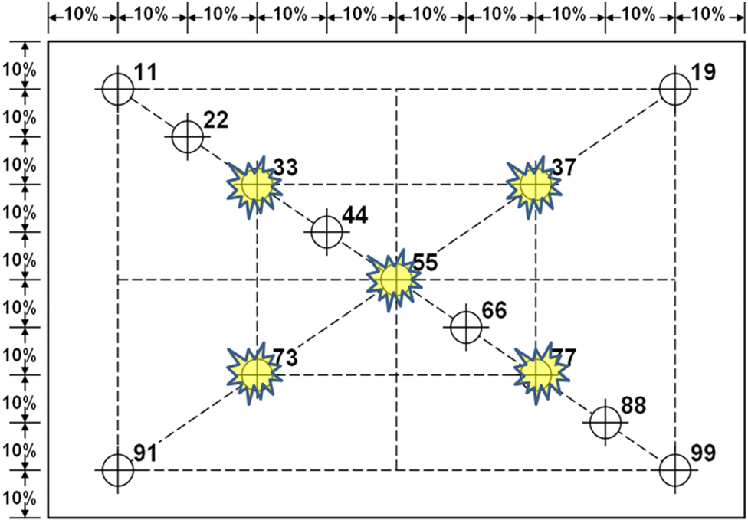
The typical LCD panel varies in luminance from point to point on the screen. Because of this fact it is a good practice to take five separate measurements on the screen surface and compute the average. EBL uses a variation of the industry standard ISO 13406-2 Ergonomic requirements for work with visual displays based on flat panels. EBL uses the five points labeled 33, 37, 55, 73, and 77 to compute average luminance of the panel.
LCD Panel measurement template, 5 locations highlighted with
yellow stars are used for EBL measurements.

Average Luminance =
(L₃₃ + L₃₇ + L₅₅ + L₇₃ + L₇₇)
5

EBL Flowchart

Black-White Checkerboard at 60 nits
Display checker pattern
Warm panel VESA 303-5 or 30 min *

Set panel to 60 nits

Record results
Display white pattern

Note: No additional warm-up period required if panel has already reach full operational temperature

Black-White Checkerboard at maximum brightness
Display checker pattern
Warm panel VESA 303-5 or 30 min *

Set panel to full brightness

Record results

Note: No additional warm-up period required if panel has already reach full operational temperature

Full White pattern at maximum brightness
Display full white pattern
Warm panel VESA 303-5 or 30 min *

Set panel to full brightness

Record results

Note: No additional warm-up period required if panel has already reach full operational temperature

Full Red pattern at maximum brightness
Display full red pattern
Warm panel VESA 303-5 or 30 min *

Set panel to full brightness

Record results

Note: No additional warm-up period required if panel has already reach full operational temperature

Full Blue pattern at maximum brightness
Display full blue pattern
Warm panel VESA 303-5 or 30 min *

Set panel to full brightness

Record results

Note: No additional warm-up period required if panel has already reach full operational temperature

Full Green pattern at maximum brightness
Display full green pattern
Warm panel VESA 303-5 or 30 min *

Set panel to full brightness

Record results

Note: No additional warm-up period required if panel has already reach full operational temperature

Full Black pattern at maximum brightness
Display full black pattern
Warm panel VESA 303-5 or 30 min *

Set panel to full brightness

Record results

Note: No additional warm-up period required if panel has already reach full operational temperature

Reference Documents
VESA FPDM version 2.0 - Flat Panel Display Measurement guide (www.vesa.org)
EBL - Mobile PC Extended Battery Life Procedure (http://www.eblwg.org/pubdocs.asp)

Definitions
LCD Cell – Color filter glass and thin film resistor glass separated by liquid crystal.

Backlight – Module normally found behind LCD Cell that produces light.

Ambient Light – The light the surrounds the DUT http://en.wikipedia.org/wiki/Ambient_light
DUT – display under test
Viewing direction – Extent that panel can be tilted or turned away from viewer http://en.wikipedia.org/wiki/Viewing_angle
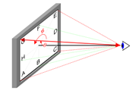
Viewing cone – Extent that panel can be tilted or turned away from viewer while retaining acceptable performance http://en.wikipedia.org/wiki/Viewing_cone
cd/m² or nit – Common unit of screen luminance http://en.wikipedia.org/wiki/Nit_(unit)
Lux – Common unit of light intensity http://en.wikipedia.org/wiki/Lux

Appendix A – Alternative to DMM tool

The measurement configurations in this document recommend using a Digital Multi Meter measuring DC (direct) current; however, DMMs are not the only current measuring device that may be used. Oscilloscopes, data recorders, and precision volt meters can also be used. Current can be computed as a voltage drop across a sense (series) resistor as illustrated below:
To measure current, Ohm’s Law is applied to the sense resistor example as follows:
Current = V/R
where:
V = Voltage drop from V_{source} – V_{load}
R = Resistance in Ohms. (Note: a small precision R value (1 Ohm or less) is recommended to avoid excessive voltage drop between the Cell (TFT) or Backlight and voltage source.)
(SAMPLE DATA)
V (measured) = 270 mV
R (given) = 1.0 Ohms
Current (computed) = V / R
= 270 mV / 1.0 Ohms
= 270 mA
Note: Meter in example is a generic image not intended to specify any brand or model.

Appendix B – Configuration using CRB
For a complete description of using Intel CRB to make EBL power measurements the Mobile PC Display Power Measurement Recommendations v1.0 can be downloaded from EBL website
(http://www.eblwg.org/pubdocs.asp).

Appendix C – Efficiency Measurements

Configuration to compute CCFL inverter efficiencies

DMM (DC mode)
LCD Panel
Cold Cathode Fluorescent Lamp
1K Ohms
HV
RTN
I_{IN}
Inverter
Input
Current
DMM (VAC mode)
Min. 150 kHz BW,
True RMS Readings
AC Lamp Current (I_{OUT})
V1_{RMS}

V2_{RMS}
Return
High Voltage
Input Side
Output Side
CCFL Inverter
V_{IN}
Inverter
Input
Voltage
(Typ. 12 VDC)
Directly Measure Inverter V_{OUT} = V1_{RMS}
Calculate Inverter I_{OUT} = V2_{RMS} / 1K Ohms

Inverter Input Power (P_{IN}) = Inverter Input Voltage x Inverter Input Current = V_{IN} x I_{IN} (Watts)
Inverter Output Power (P_{OUT}) = Inverter Output Voltage x Inverter Output Current = V1_{RMS} x I_{OUT}
CCFL Inverter Efficiency = P_{OUT} / P_{IN} x 100% = (V_{IN} x I_{IN}) / (V1_{RMS} x I_{OUT}) x 100%
Note: CCFL backlight inverters output high voltage (600 ~ 2000 VAC) to the CCFL bulb. Great care must be taken to avoid contact with high voltage components; use a suitable DMM with High Voltage AC rating sufficient to safely handle the direct V_{OUT} (V1_{RMS}) measurement.

Configuration to compute LED efficiencies

Panel developers may want to characterize LED efficiencies.
I_{out}
V_{out}
I_{in}
V_{in}

LED Controller
System Power 3v - 5v
LED Power +12v
Row 1
Row 2
Row 3
Row n
LED 1
LED 2
LED 3
LED n
LED Power (P_{IN}) = LED Controller Input Voltage x LED Controller Input Current = V_{in} x I_{in} (Watts)
LED Power (P_{OUT}) = LED Controller Output Voltage x LED Controller Output Current = V_{out} x I_{OUT}
LED Efficiency = P_{OUT} / P_{IN} x 100% = (V_{IN} x I_{IN}) / (V_{out} x I_{out}) x 100%

Appendix D – EBL Levels Report

Level Procedure
Portable system designers need to understand power consumption at many different level of brightness. To provide a detailed characterization of panel performance from minimum to maximum brightness, an optional panel performance report and procedure has been developed.
To ensure an even coverage of the entire range from 0% to 100% duty cycle, the report breaks down the range into 16 levels evenly spaced from 0% to 100% duty cycle. Panels that use digital backlight controllers use the same process from step 0 to step 255 in 16 equally space increments.
Digital or PWM based backlight controllers are both supported by the LEVELS report contained in the EBL Report tool provided on http://www.eblwg.org. Digital users enter their data in 16 equally spaced steps into the chart, PWM users enter PWM duty cycles percentages in 16 equal steps.

EBL Level Configuration

Panel configuration is same as standard EBL configuration. Power is measured at input to panel logic and backlight control.
BL
data
Back Light Control
Logic Controller

Liquid Crystal Display
Column Driver
Row Driver
Light Source
System Power
Backlight Power 12v
DC Current Meters

EBL Level Flowchart

Set B/L to minimum luminance

Warm panel VESA 303-5 or 30 min *

Record results
Set B/L to next level

Display Full White Pattern

Level Report

The Level report records all the raw characterization data at each level and report in with two very easy to use graphs, NITS TO DUTY CYCLE and NITS TO WATTS. Both graphs are very valuable to system designers.

